.

Minimization of Leakage Current and Frequency Range Determination in Transformer-less Inverters for Photovoltaic On-Grid Systems
A Thesis submitted in partial
fulfillment for the requirement of the
Degree of
Bachelor Science in
Electrical and Electronic Engineering
Submitted by
Robiul Hosen(19EEE002)
Razowan Kabir(19EEE037)
Most.Murshida Khatun(19EEE044)
Pantho Mondol(19EEE045)
To the Department of Electrical and Electronic Engineering
Gopalganj Science and Technology University, Gopalganj -8100
September, 2025

ACKNOWLEDGEMENT
The Thesis has been submitted to the Department of Electrical and Electronic Engineering of Gopalganj Science and Technology University, Gopalganj-8100 for the partial fulfillment of the requirement for the degree of B.Sc. in Electrical and Electronic Engineering.Thesis title regards “Minimization of Leakage Current by Frequency Range Determination & Increasing. Thermal Efficiency in Transformer-less Inverters for Photovoltaic On-Grid Systems”
First and foremost,We offer my sincere gratitude and indebtness to our thesis supervisor Dr.A.T.M Saiful Islam,Associate professor,Department of Electrical and Electronic Engineering who has supported us throughout our thesis with his patience and knowledge.We shall ever remain grateful to him for his valuable guidance, advice, encouragement, cordial and amiable contribution to my thesis.
We wish to thank once again Dr.A.T.M Saiful Islam as the coordinator of the Department of Electrical and Electronic Engineering for his support and encouragement and also for providing all kind of laboratory facilities.
We would like to express my deep gratitude to Dr.A.T.M Saiful Islam.He has always encouraged me during our research. We also grateful to the Department of Electrical and Electronic Engineering at Gapalganj Science and Tecnology University, Gopalganj-8100 for providing the resources and platform necessary to conduct this study.
Also we would like to thank all of my friends for their cordial encouragement and help during the thesis work.
Finally,We wish to express my gratitude to my parents and other members of my family for their inspiration, trust, and support who have taught me about of Electrical and Electronic Engineering.

CERTIFICATE
This is to certify that the thesis entitled “Minimization of Leakage Current and Frequency Range Determination in Transformer-less Inverters for Photovoltaic On-Grid Systems” being submitted by the following students:
Robiul Hosen(19EEE002)
Razowan Kabir(19EEE037)
Most.Murshida Khatun(19EEE044)
Pantho Mondol(19EEE045)
From Gopalganj Science and Technology University, Gopalganj-8100 has been carried out under my supervision for impartial fulfillment of the requirements for the degree of Bachelor of Science in Electrical and Electrical Engineering.The quality of the thesis is satisfactory.

Signature of Supervisor

Dr.A.T.M. Saiful Islam
Associate Professor
Department of EEE
Gopalganj Science and Technology University, Gopalganj -8100

ABSTRACT
The distributed energy resources , especially photovoltaic(PV) systems, into the grids have gained major attention due to their environmental and economic benefits. Although transformer-based grid connected photovoltaic inverter gives galvanic isolation for leakage current, it suffers from some drawbacks of high cost, lower efficiency, and increased size. Transformer-less inverters are widely used in different photovoltaic nonisolated ac modules applications, due to their higher efficiency, compact design, and lower cost. However transformer-less-grid-connected PV inverter(TLGI) is highly affected by the leakage current caused by the fluctuation of common mode voltage(CMV), due to the lack of galvanic isolation. This paper investigates three topologies H4, H5, and HERIC with the common mode voltage and differential mode voltage, total harmonic distortion(THD), and leakage current by changing frequency range.A simulation was done for each topologies in MATLAB(Simulink) R2025b and from the result we find that the topology gives a very low leakage current, reduced THD, and optimal operation efficiency between a frequency rage and making it suitable for practical applications.

Table of Contents

List of Figures

List of Tables

List of Abbreviations
PV Photovoltaic
PWM Phase Width Modulation
IGBT Insulated Gate Bipolar Transistor
MOSFET Metal Oxide Semiconductor Field Effect Transistor
THD Total Harmonic Distortion
FFT Fast Fourier Transform
EMI Electronic Interface
FB Full Bridge
HB Half Bridge
HERIC Highly Efficient and Reliable Inverter Concept
HF High Frequency
LF Low Frequency
IEA PVPS International Energy Agency Photovoltaic Power Systems
MPP Maximum Power Point
AC Alternating Current
DC Direct Current
BPDP Bangladesh Power Development Board
PF Power Factor

List of Symbols

Chapter 1
Introduction

1.1 Background of Renewable Energy and Photovoltaic Systems.

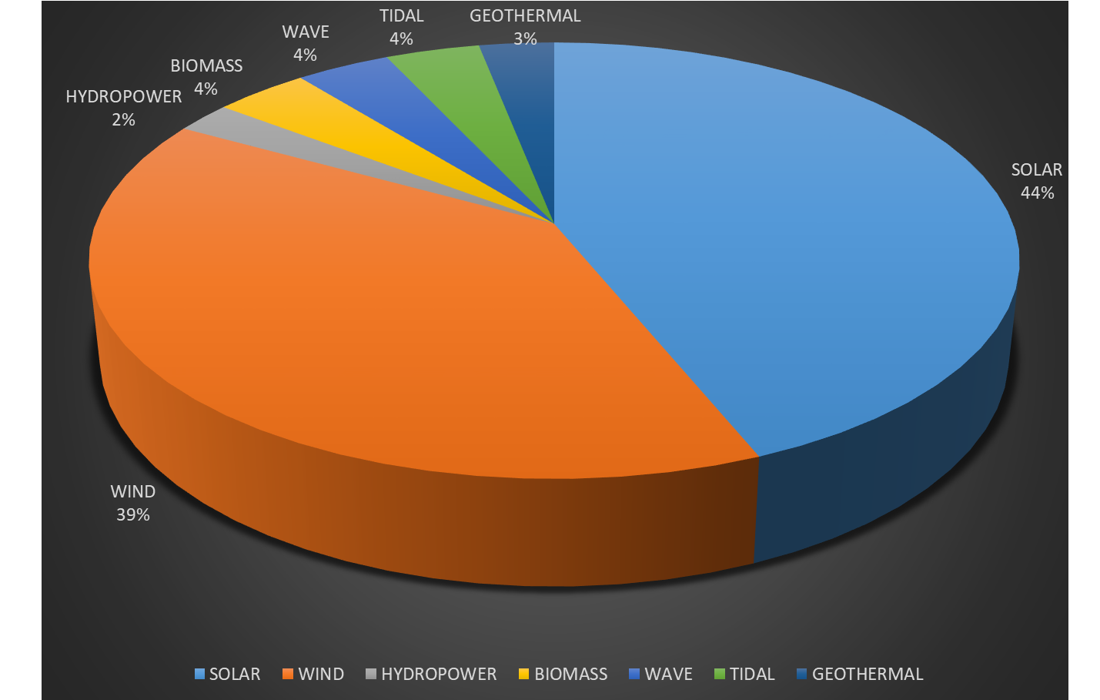
In recent decades, the increasing global energy demand and environmental concerns have accelerated the transition from fossil fuels to renewable energy sources. Among various renewable options, solar photovoltaic (PV) technology has emerged as one of the fastest-growing and most reliable sources of clean electricity. PV systems directly convert sunlight into electrical energy using semiconductor materials, offering a sustainable and scalable solution for power generation. With declining costs of PV modules and supportive government policies, large-scale grid integration of solar energy has become a practical reality.

Figure 1: Global renewable energy contribution with focus on PV growth.

1.2 On-Grid PV Systems and the Role of Inverters
In on-grid PV systems, inverters play a crucial role in converting the direct current (DC) generated by solar panels into alternating current (AC) that can be fed into the utility grid. Besides simple conversion, inverters are also responsible for maintaining power quality, grid synchronization, and ensuring compliance with grid codes. The efficiency of the inverter largely determines the overall performance of the PV system. Traditionally, transformer-based inverters were widely used due to their ability to provide galvanic isolation and ensure safety. However, they are bulky, expensive, and less efficient compared to transformerless inverters. $1∅/3∅$

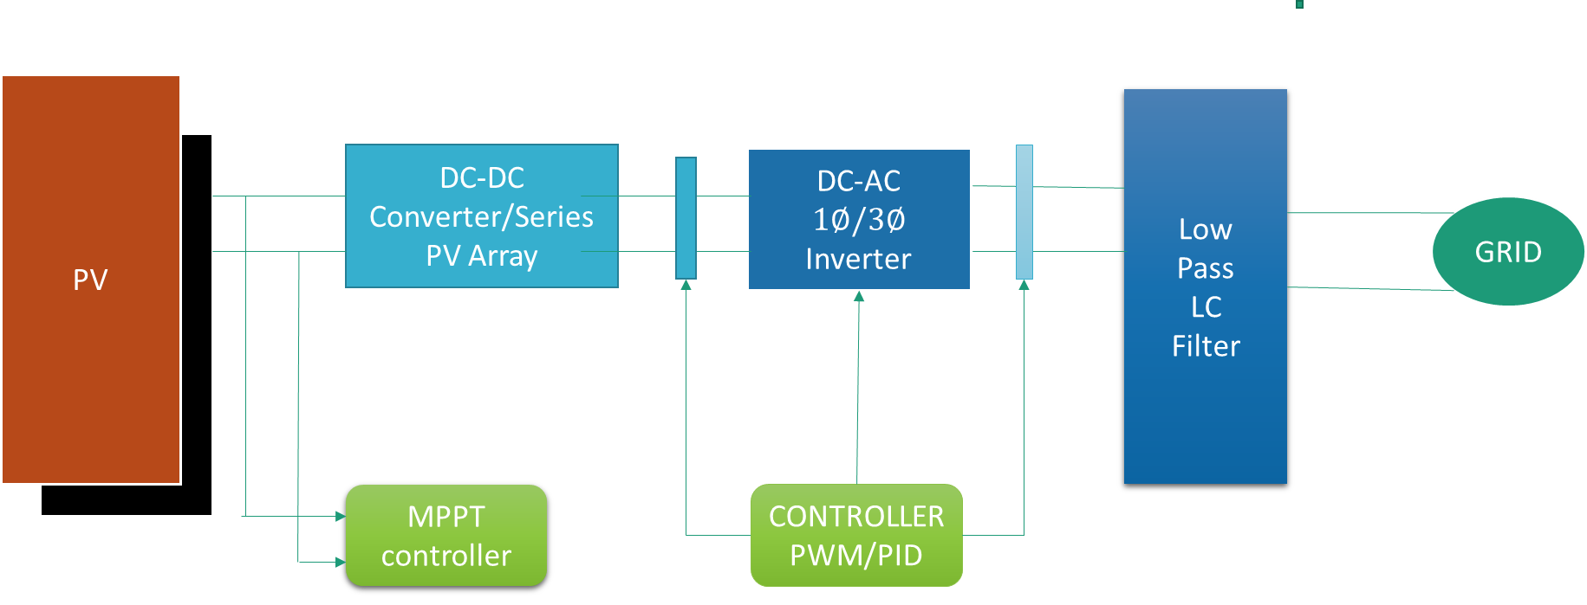
Figure 2: Block diagram of a grid-connected PV system highlighting the inverter stage
1.3 Transformerless Inverters: Advantages and Challenges

Transformerless inverters have gained significant attention due to their high efficiency, compact design, and reduced cost. By eliminating the line-frequency transformer, power losses and system weight are minimized, resulting in an overall efficiency improvement of 1–2%. However, the absence of galvanic isolation introduces challenges, particularly the issue of common-mode voltage (CMV) and leakage current. These effects arise due to parasitic capacitance between the PV panel and ground, which can compromise system safety and reliability if not properly controlled.
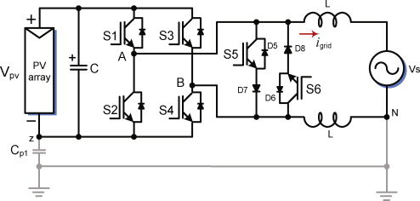
Figure 3: Transformerless inverter architectures(HERRIC TOPOLOGY)
1.4 Leakage Current in PV Systems

Leakage current in transformerless PV systems is primarily caused by the parasitic capacitance between the PV array and ground. This current flows through unintended paths, posing risks such as electromagnetic interference (EMI), reduced efficiency, potential hazards to maintenance personnel, and violation of grid safety standards. The magnitude of leakage current is influenced by the inverter topology, switching frequency, modulation scheme, and grounding configuration. Therefore, minimizing leakage current is a key requirement for transformerless inverter design.

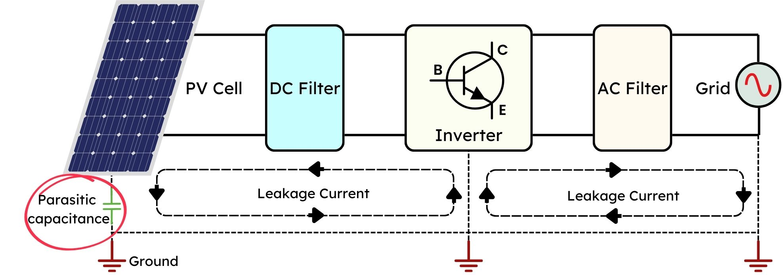

Conducting Surface
Conducting Surface
PV Cells
Capacitance
Frame
Frame
Glass
Substance

1. 5 Switching Frequency and Its Significance

Switching frequency plays a vital role in determining the performance of transformerless inverters. Higher switching frequencies can reduce the size of passive components such as filters but may also increase switching losses and thermal stress on power devices. Furthermore, switching frequency directly affects the behavior of leakage current and the spectral distribution of harmonics. Determining the optimal frequency range is therefore essential to achieving a balance between efficiency, leakage current minimization, and power quality.

*Figure 5:* Graphical relationship between switching frequency, efficiency, and leakage current.
6. Existing Solutions and Research Gaps

Several inverter topologies such as H5, HERIC, and Neutral Point Clamped (NPC) have been developed to address leakage current issues. Control techniques including unipolar and bipolar PWM modulation have also been investigated for leakage mitigation. While these approaches offer improvements, challenges remain in balancing leakage current reduction, maintaining high efficiency, and ensuring reliable operation across varying conditions. Moreover, limited work has been carried out on systematically determining the optimal frequency range in relation to leakage current performance.

*Figure 6:* Common transformerless inverter topologies with leakage control strategies.

7. Problem Statement and Motivation of the Study

Although transformerless inverters are widely used for grid-connected PV systems, leakage current remains a significant barrier to their safe and efficient operation. At the same time, the selection of switching frequency is often based on practical design considerations rather than systematic analysis of leakage performance. This research is motivated by the need to minimize leakage current while determining the optimal frequency range that ensures efficient, safe, and reliable grid integration of PV systems.

8. Objectives of the Thesis

The main objectives of this study are as follows:

* To analyze leakage current behavior in transformerless inverter topologies for PV systems.
* To investigate the effect of switching frequency on leakage current and inverter efficiency.
* To determine an optimal frequency range that minimizes leakage current without compromising power quality.
* To validate the proposed approach using simulation and experimental analysis.

